ESP8266(LiLon NodeMCU V3)

Get started
Arduino setup (from https://www.instructables.com/id/Getting-Started-With-ESP8266LiLon-NodeMCU-V3Flashi/)
- File → Preferences…
- Additional Boards Manager URL: http://arduino.esp8266.com/stable/package_esp8266com_index.json
OK
- Tools → Boards → Boards Manager
- Search: esp8266
Install
- Tools → Boards → NODEMCU 1.0 (ESP - 12E Module)

Pin usage
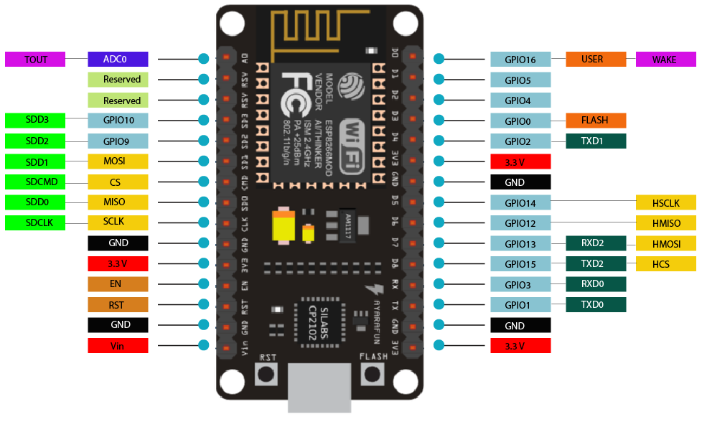

GPIO Pin | I/O Index Number | Label | Input | Output
GPIO0 | 3 | D3 | pulled up | OK | connected to FLASH button, boot fails if pulled LOW
GPIO1 | 10 | TX | TX pin | OK | HIGH at boot, debug output at boot, boot fails if pulled LOW
GPIO2 | 4 | D4 | pulled up | OK | HIGH at boot  connected to on-board LED, boot fails if pulled LOW
GPIO3 | 9 | RX | OK | RX pin | HIGH at boot
GPIO4 | 2 | D2 | OK | OK | often used as SDA (I2C)
GPIO5 | 1 | D1 | OK | OK | often used as SCL (I2C)
GPIO6 | N/A
GPIO7 | N/A
GPIO8 | N/A
GPIO9 | 11
GPIO10 | 12
GPIO11 | N/A
GPIO12 | 6 | D6 | OK | OK | SPI (MISO)
GPIO13 | 7 | D7 | OK | OK | SPI (MOSI)
GPIO14 | 5 | D5 | OK | OK | SPI (SCLK)
GPIO15 | 8 | D8 | pulled to GND | OK | SPI (CS)  Boot fails if pulled HIGH
GPIO16 | 0 | D0 | no interrupt | no PWM or I2C support | HIGH at boot, used to wake up from deep sleep
ADC0 |  | A0 | Analog input | X

Use either D-number, ie “D0”, or GPIO-number, ie “16”

Test code
will create a web page to set an LED
#include <ESP8266WiFi.h>
const char* ssid = "Magesh";
const char* password = "jayakumar";
int ledPin = 13; // GPIO13
WiFiServer server(80);
void setup() {
Serial.begin(115200);
delay(10);
pinMode(ledPin, OUTPUT);
digitalWrite(ledPin, LOW);
// Connect to WiFi network
Serial.println();
Serial.println();
Serial.print("Connecting to ");
Serial.println(ssid);
WiFi.begin(ssid, password);
while (WiFi.status() != WL_CONNECTED) {
delay(500);
Serial.print(".");
}
Serial.println("");
Serial.println("WiFi connected");
// Start the server
server.begin();
Serial.println("Server started");
// Print the IP address
Serial.print("Use this URL to connect: ");
Serial.print("http://");
Serial.print(WiFi.localIP());
Serial.println("/");
}
void loop() {
// Check if a client has connected
WiFiClient client = server.available();
if (!client) {
return;
}
// Wait until the client sends some data
Serial.println("new client");
while(!client.available()){
delay(1);
}
// Read the first line of the request
String request = client.readStringUntil('\r');
Serial.println(request);
client.flush();
// Match the request
int value = LOW;
if (request.indexOf("/LED=ON") != -1) {
digitalWrite(ledPin, HIGH);
value = HIGH;
}
if (request.indexOf("/LED=OFF") != -1) {
digitalWrite(ledPin, LOW);
value = LOW;
}
// Set ledPin according to the request
//digitalWrite(ledPin, value);
// Return the response
client.println("HTTP/1.1 200 OK");
client.println("Content-Type: text/html");
client.println(""); // do not forget this one
client.println("<!DOCTYPE HTML>");
client.println("<html>");
client.print("Led pin is now: ");
if(value == HIGH) {
client.print("On");
} else {
client.print("Off");
}
client.println("<br><br>");
client.println("<a href=\"/LED=ON\"\"><button>Turn On </button></a>");
client.println("<a href=\"/LED=OFF\"\"><button>Turn Off </button></a><br />");
client.println("</html>");
delay(1);
Serial.println("Client disonnected");
Serial.println("");
}

